**Battles and the High Seas (BATHS) Part 2**

Module: 5COM2007

|  |
| --- |
| Team Members |

|  |  |
| --- | --- |
| Name | ID Number |
| Fatimah Aldreby | 22046611 |
| Abdul Awan | 22079675 |
| Iman Khan | 23002248 |
| Taybah Noor | 22044316 |

**Project Management**

Week of 17/03

* **Communication**

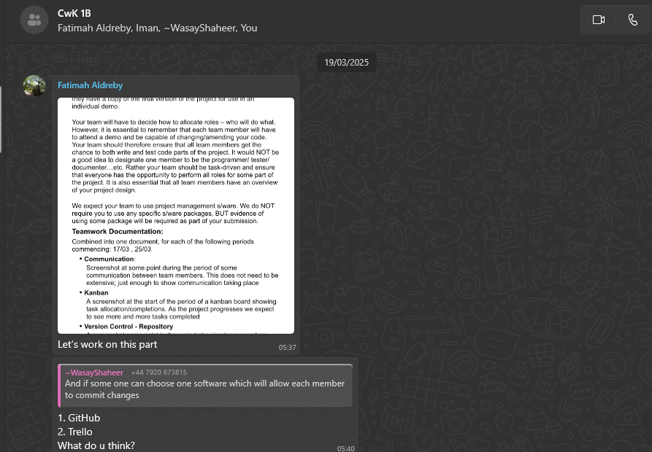Communication Screenshots (Used WhatsApp):

During the week of 17/03, our team made effective use of WhatsApp. We had a designated group chat titled "CwK 1B" where each of the four team members contributed regularly. In this chat, we allocated each task, provided updates regarding individual progress, and shared quick questions or concerns. For example, we discussed setting up local repositories, agreed on class designs, and shared reminders for commits. This guaranteed there was effective collaboration throughout the week.

* **Kanban Board**

Throughout the project, we used Monday.com to actively manage our tasks and our progress. There was a board that had four columns: To Do, In Progress, Meeting, and Done. This arrangement was helpful in that it allowed us to keep track of the task distribution in a clear and transparent way across the whole team.

Screenshots of Kanban board taken on the 21st of March:

We concentrated on laying the groundwork of the project during the week of March 17. Tasks included setting up GitHub, distributing team roles, and starting development of the SeaBattles.java class. We also made a start on the test plan and had meetings to get everyone on the same page since we all approach our work differently. The very first set of completed tasks are shown in the Done column and reveal an excellent collaborative start as the team brought in their best.

* **Version Control (GitHub)**

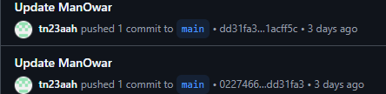Screenshots showing commit activity by team members on the 21st of March:

During the week of 17/03, each member of the team contributed to the GitHub repository. Fatimah had uploaded all the project files like the tester, subclasses, and early project documents. Iman made numerous commits uploading Java files and tidied up some of the project directory. Abdul started implementing the backend.java (SeaBattles) file and had made commits to it. Taybah also implemented some changes to the ManOWar class, and in general, the whole team put effort in early and helped set the foundation for the remainder of the project.

**Week of 25/03**

* **Communication**

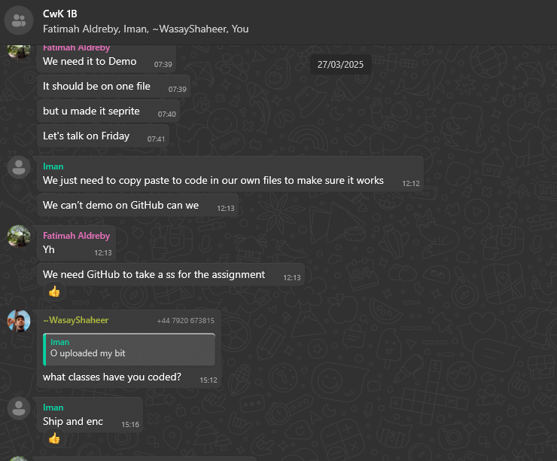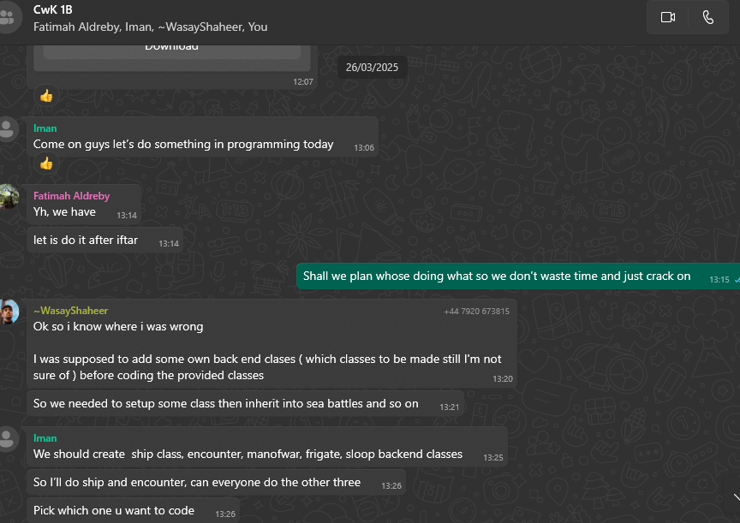Communication Screenshots:

In the week of 25/03, our group continued communicating actively through our WhatsApp group chat. We used this time to plan how we would divide the remaining tasks, such as who would take on the different supplier java classes. We discussed challenges we faced during implementation, shared coding progress, and decided on when to meet up or provide updates. Everyone got involved in assigning responsibilities and helping each other figure out what needed to be done next. The group chat helped us stay organised and made sure no one was left behind as we moved into the final stages of the project.

* **Kanban Board**

Update of the Kanban board taken on the 28th of March and 4th of April:

In the week of 25th March, we continued to use Monday.com to actively manage our progress. The Kanban board clearly shows how we tracked development tasks across the To Do, In Progress, Meetings and Done columns. This week was heavily focused on technical refinement and completion of tasks.

**Key activities included:**

* Helping each other as a team with adding tester to Netbeans, which reflects strong collaboration.
* Running the WarTesting package and debugging JUnit tests on NetBeans.
* Finalising the coding of the SeaBattles.java methods.
* Completing the Test Plan and beginning Task 3 report writing.
* Helping each other as a team with adding tester to Netbeans, which reflects strong peer support.

The Done column shows clear progress, with critical tasks like writing Java subclasses and gathering resources for the challenge already completed. To ensure a balanced load, each assignment was assigned to a specific member and labelled with a priority level (e.g., High, Medium).

All things considered, this board shows a successful and well-structured development phase in which our team demonstrated excellent collaboration.

* **Version Control (GitHub)**

Screenshots showing commit activity by team member:

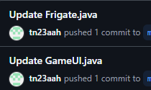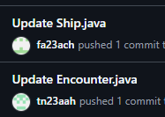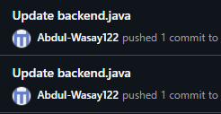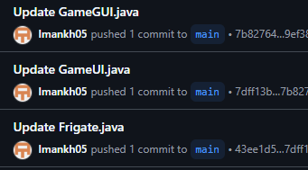

The GitHub commits prove that the entire team worked together on the major parts of the project. Iman, Abdul, Taybah and Fatimah all contributed to the SeaBattles.java file, which proves that they worked together as a team on the fundamental game code. Iman edited the Frigate, Ship, Encounter, and GameUI/GUI classes, while Fatimah edited Ship.java. Moreover, Taybah made several changes in Frigate and Encounter classes, while Abdul edited the SeaBattles class. These updates show that the team made steady progress and worked well together to create the main aspects of the game.